1. Introduction

The purpose of this application note is to help users design EZRadioPRO® PCBs using design practices that allow for good RF performance. This application note also help designers by separating TX and RX concerns.
The RF performance and the critical maximum peak voltage on the output pin strongly depend on the PCB layout as well as the design of the matching networks. For optimal performance, Silicon Labs recommends the use of the PCB layout design hints described in the following sections.
- 简介
这个应用文档是帮助用户设计RF性能最佳的EZRadioPRO® PCBs，还有助于关注TX和RX分离的设计师。
射频的性能和主要输出引脚上的峰值电压主要由PCB的布局决定，也有匹配网络决定。Silicon Labs的最佳性能，使用的PCB布局建议如以下章节的提示。
2. Design Recommendations when Using EZRadioPRO RF ICs

■ Extensive testing has been completed using reference designs provided by Silicon Labs. It is recommended to designers to use the reference designs “as-is” since they minimize detuning effects caused by parasitics, component placement, and PCB routing.
■ When layouts cannot be followed as shown by the reference designs (due to PCB size and shape limitations), the following layout design rules are recommended.

2 使用EZRadioPRO RF ICs 的设计建议

使用由Silicon Labs已经完成的参考设计多去测试，这是推荐给设计师使用的设计方案，为了尽量减小失谐影响，通常是由寄生效应、元件布局、PCB布线等引起的。
当布局不能遵循如下的设计参考时（由于PCB的尺寸和形状的限制），则应遵循如下的设计参考规则。
2.1. Guidelines for Layout Design when Using the Si4430/31

The Si4430/31 devices use a Class-E type TX matching network with a typical output power level of +13 dBm at VDD = 3.3 V. Two basic types of board layout configurations exist at all frequency bands: the Split TX/RX type and the Direct Tie type. In the Split TX/RX type, the TX and RX paths are separated, and individual SMA connectors are provided for each path. In the Direct Tie type, the TX and RX paths are connected together directly, without any additional RF switch. The operating principle of both types and the reference designs with element values are given in “AN436: Si4030/4031/4430/4431 PA Matching” for wirewound and multilayer type 0402 size SMD inductances as well.

The Split and Direct Tie type boards have slightly different PCB layouts, which are described in separate sections
2.1 Si4430/31使用的设计准则

Si4430/31器件使用一个典型的E类型TX匹配网络，在VDD等于3.3V的电压时具有+13dB的输出功率。其中这两个基本的布局类型可以满足所有的频段：TX/RX分开的类型和直接连接的类型。在TX/RX分割的类型中，TX和RX的路径是分开的，SMA连接器对应各自的路径。在直接连接的类型中，TX和RX的路径是直接连在一起的，没有额外的RF开关。这两种类型的工作原理和设计原件的参考值也在“AN436: Si4030/4031/4430/4431 PA 匹配”线绕和多层型的0402尺寸的SMD电感。
分割和直接的板子略有不同的PCB布局，在单独的章节中进行叙述。

2.1.1. Split Type Matching Network Layout Based upon the 4431-T-B1_B Test Card
(Separate TX and RX Paths with Two Antennas)

Examples shown in this section of the guide are based upon the layout of the 4431-T-B1_B test cards. These cards contain two separate antennas for the TX and RX paths. This type of test card is best suited for demonstrating the output power and sensitivity of the EZRadioPRO RFICs. For this purpose, the TX and RX path layouts are separated and isolated as much as possible to minimize the mutual coupling effects. This type of test card is recommended for laboratory evaluation and not for range tests because the presence of two closely-spaced antennas may cause “shadowing” when receiving a radiated signal.

The main layout design concepts are reviewed through this layout to demonstrate the basic principles. However, for an actual application, the layouts of the test cards with a single antenna (or with antenna diversity) should be
used as references. The schematic of the Split type matching network for Si4431 RevB1 is shown in Figure 1.

2.1.1 依据4431-T-B1_B测试卡的分割类型的网络匹配布局（分开TX和RX的路径带两个天线）
在本节的指导示例是基于布局的4431 - T B1_B的测试卡。这些卡包含两个独立的天线TX和RX路径。这种类型的测试卡是最适合展示EZRadioPRO RFIC的输出功率和灵敏度。为此，TX和RX路径布局分开，并尽可能地隔离，以尽量减少相互的耦合效应。这种类型的测试卡，建议实验室评估，而不是范围的测试，因为两个密集的天线可能会导致“阴影”当接受到辐射信号的时候。
对主要布局的设计理念进行审查，通过这种布局表现出的基本原则。然而， 实际应用中，应与单个天线（或天线多样性）的测试卡的布局用作参考。 Si4431 RevB1分体式匹配网络的原理图如图1所示。
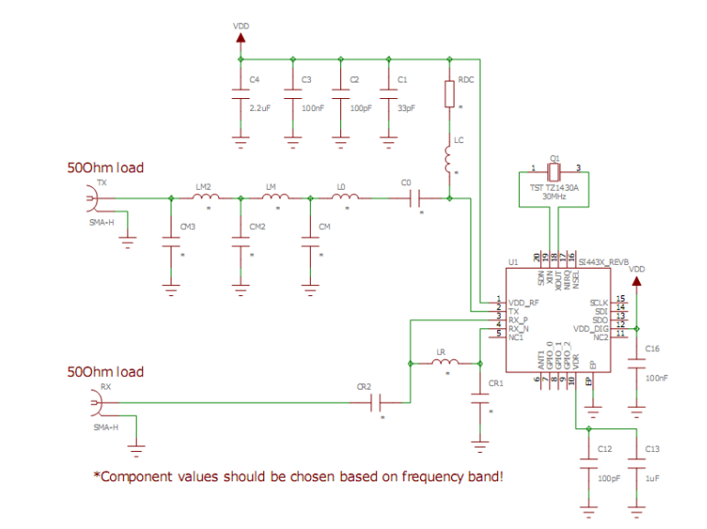
Figure 1. 分割的匹配网络的原理图（SI4431 RevB1）
分割模式的布局结构在图2中
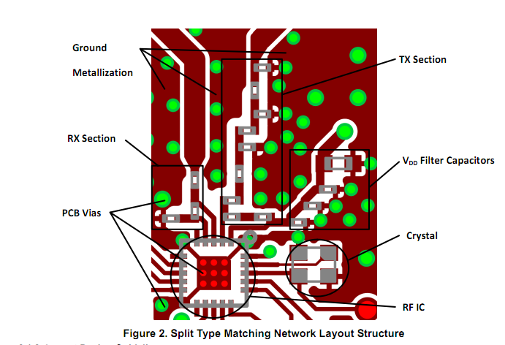

2.1.2. Layout Design Guidelines

■ The choke inductor (LC) should be placed as close to the TX pin of the RF IC as possible (even if this means the RX is further away).
■ The parallel inductor in the RX path (LR) should be perpendicular to the choke inductor (LC) in the TX path because this will reduce TX-to-RX coupling.
■ The TX and RX sections should be separated by a GND metal on the top layer to reduce coupling.
■ The neighboring matching network components should be placed as close to each other as possible in order to minimize any PCB parasitic capacitance to ground and the series parasitic inductances between the components.
■ Increase the grounding effect in the thermal straps used with capacitors. In addition, thicken the trace near the GND pin of these capacitors. This will minimize series parasitic inductance between the ground pour and the GND pins. Additional vias placed close to the GND pin of capacitors (thus connecting it to the bottom layer GND plane) will further help reduce these effects.

    - 布局设计指南
- 扼流圈电感（LC）应该尽可能的靠近在TX引脚上(那就意味着RX引脚将远离)
- 在RX路径上并联电感器（LR）应垂直于扼流电感（LC）的TX路径因为这将减少发送到接收耦合。
- TX和RX部分应分开由接地金属在顶层填充，以减少耦合。
- 邻近的匹配网络元件应放在对方尽可能接近，以尽量减少任何PCB对地的寄生电容和在组件之间的寄生电感。
- 增加接地效果在与电容所使用的热肩带旁边。此外，要加厚这些电容器的GND引脚附近的轨迹。这将最大程度的减少在接地引脚和大地的寄生电感。额外的防治一些通孔（它连接到底层的GND平面）在电容接地的引脚旁边将减少这种影响

Figure 3 illustrates the positioning and orientation of the LC and LR components, the separating GND metal between the TX and RX sections, and thermal strapping on the shunt capacitors.

图3所示的LC和LR组件的定位与方向， TX和RX之间部分金属分离GND，并联电容器与与地的连接等。
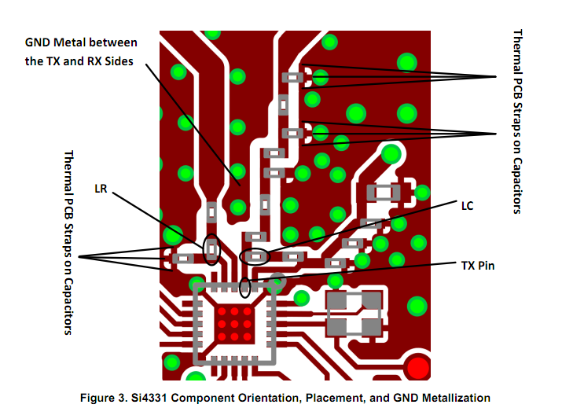 Nearby inductors of the TX path should be kept perpendicular to each other to reduce coupling between stages of the low-pass filter and match. This helps to improve filter attenuation at higher harmonic frequencies.
■ Use at least 0.5 mm separation between traces/pads to the adjacent GND pour in the areas of the matching networks. This minimizes the parasitic capacitance and reduces detuning effects.

TX路径附近的电感应该相互垂直，以来减少在低通滤波器阶段和匹配之间的耦合。这有助于提高高次谐波频率的衰减。
在匹配网络上，走线或焊盘与相邻地之间的距离应该至少在0.5mm以上。这样尽可能的减少寄生电容效应和失谐影响。
Figure 4 illustrates the orientation of the inductors of the TX path and the separation of the matching network traces/pads from the GND metal.
图4说明了TX路径的电感器方向和匹配网络上走线或焊盘与接地金属的分离方式
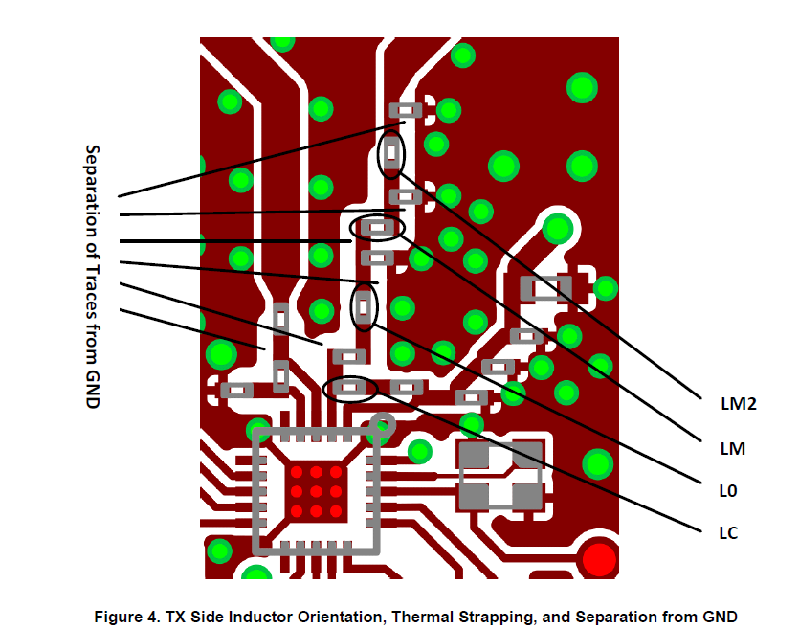
■ The smaller VDD bypass capacitors (C1 = 33 pF and C2 = 100 pF) should be kept as close to the VDD pin as possible.
■ The exposed pad footprint for the paddle of the RF IC should use as many vias as possible to ensure good grounding and heatsink capability. In the reference designs, there are nine vias, each with 12 mil diameter. The paddle ground should also be connected to the top layer GND metal (if possible) to further improve RF grounding; this may be accomplished with diagonal trace connections through the corners of the RFIC footprint.
■ The crystal should be placed as close as possible to the RFIC to ensure that wire parasitic capacitances are kept as low as possible; this reduces any frequency offsets that may occur.
■ Place ground metal between the crystal and the VDD trace to reduce coupling effects.
- VDD引脚的旁路电容（C1=33pF和C2=100pF）应该尽可能靠近VDD引脚。
- 在RF芯片底部板上加尽可能多的过孔（裸露的焊盘）以来确保好的接地能力和散热能力。在参考设计中，有9个孔，每个孔的直径的为12mil，无线芯片底部应该尽可能的靠近顶层金属地以来尽可能的改变接地性能，可以通过该射频IC引脚的角落连接在一起。
- 晶体应该尽可能的接近于RFIC用来尽量减小寄生电容，以来减小可能发生的频率偏移。
- 放置接地金属在晶振和电源VDD引线之间来减小耦合效应。
Figure 5 illustrates the grounding of the RFIC, the crystal, and VDD filter capacitor positions, and the isolating
ground metal between the VDD trace and the crystal.
图5说明了RFIC的接地、晶振放置、以及电源的旁路电容方向。并在电源走线和晶振之间放置了接地金属。
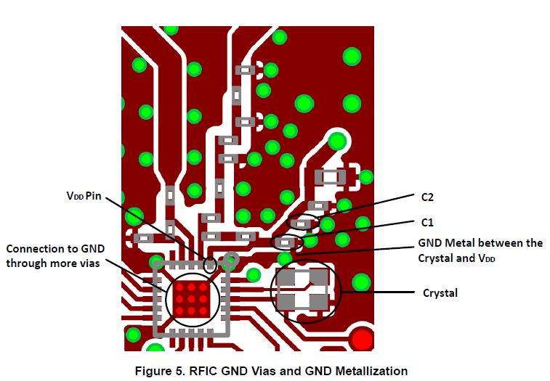
■ To achieve good RF ground on the layout, it is recommended to add large, continuous GND metallization on the top layer in the area of the RF section (at a minimum). Better performance may be obtained if this is applied to the entire PCB. To provide a good RF ground, the RF voltage potentials should be equal along the entire GND area because this helps maintain good VDD filtering and provides a good ground plane for a monopole antenna. Ideally, gaps should be filled with GND metal, and the resulting sections on the top and bottom layers
should be connected with as many vias as possible.
■ The area under the matching network (on the bottom layer) should be filled with ground metal because this helps reduce or eliminate radiation emissions. Board routing and wiring should not be placed in this region to prevent coupling effects with the matching network. It is also recommended that the GND return path between the GND vias of the TX LPF/Match and the GND vias of the RFIC paddle should not be blocked in any way; the return currents should see a clear unhindered pathway through the GND plane to the back of the RFIC.

- 为了达到最好射频接地布局，这是建议在RF部分的顶层区域最小的覆铜金属接地。若果这是应用于整个PCB将获得更好的性能，将有一个更好的射频接地效果。这样有助于保持良好的VDD过滤和提供一个良好的接地平面单极天线，射频电压电位应沿着整个接地面积相等。在理想的情况下，在接地金属填充的顶层和底层的部分的间隙中应该与尽可能多的通孔连接。
- 在网络匹配的金属下面（也就底层）应该铺满接地金属，这样有助于减小和消除辐射排放，电路板的布线和接线不应该放置在这个区域以防止和网络匹配产生耦合效应。在TXLPF的网络匹配与RFIC底部的过孔在任何时候不应该封锁，在RFIC接地的对面应该看到一个完整的过孔接入。
Figures 6 and 7 illustrate the GND metal filled sections on the entire 4431-T-B1_B test card PCB. The top and bottom layers are shown.
图6和图7说明了整个4431- T B1_B测试卡PCB上的接地金属填充的部分。顶部和底层。
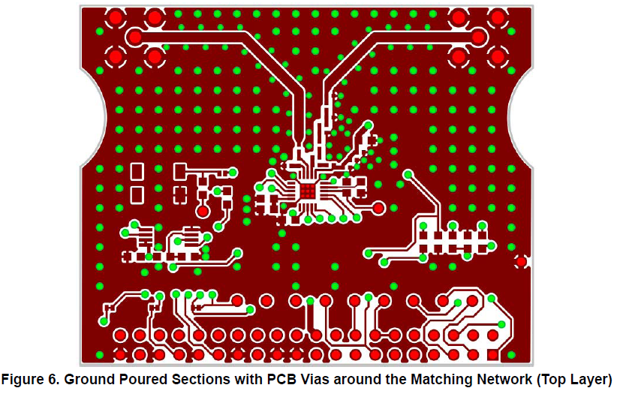
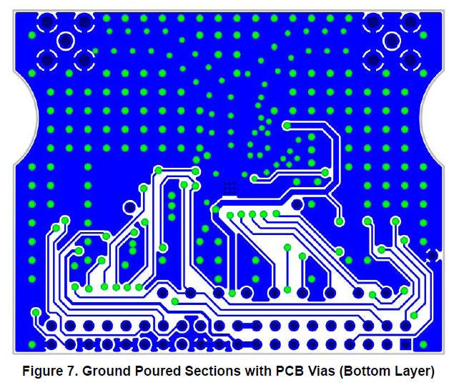

To reduce sensitivity to PCB thickness variation, use 50  grounded coplanar lines wherever possible to connect the SMA connector(s) to the matching network and/or the RF switch. This also reduces radiation and coupling effects. The interconnections between the elements are not considered transmission lines because their lengths are much shorter than the wavelength and, thus, their impedance is not critical. As a result, their recommended width is the smallest possible (i.e. equal to the width of the pad of the applied components). In this way, the parasitic capacitances to ground can be minimized. In the case of the 4431-T-B1_B type test card, the only routes where 50  coplanar transmission line is used are between the output of the matching networks and the SMA connectors. Examples for the trace dimensions are shown in Table 1.

为了减少PCB厚度变化的敏感性，用50欧接地共面线，无论如何要尽可能的连接网络匹配上的SMA器件或者RF开关，这也减少了辐射和耦合效应。不用考虑元件之间的互联传输线路，因为他们的长度比波长更短，因此，它们的阻抗不是很关键。所以推荐的宽度可能是最小的（及等于应用组件焊盘的宽度）。在这样，对地的寄生电容可以降到最低。在4431- T B1_B类型测试卡的情况下，在输出匹配网络和SMA连接器之间只用50欧共面传输线。跟踪尺寸的例子如表1所示。

图8给出了50欧接地的TX端共面线的4431- T B1_B的测试卡。
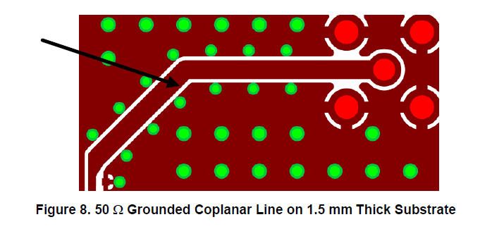
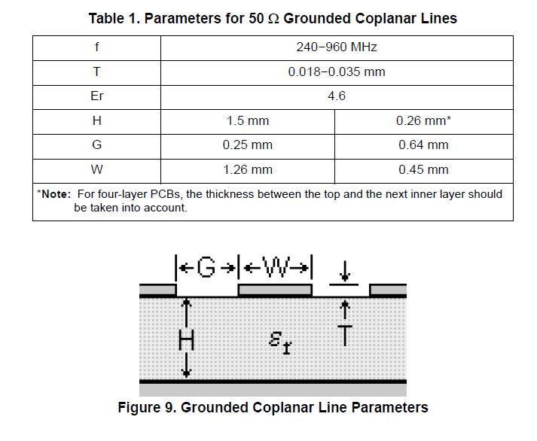

2.1.3. Direct Tie Type Matching Network Layout Based upon the 4431-T-B1_D Test Card
(Single Antenna without RF Switch)
For reference, layout examples shown in this section are based upon the layout of the 4431-T-B1_D RF test cards.These boards contain a single antenna, and the TX and RX paths are connected directly together, without the use of an RF switch.
The schematic of the Direct Tie type matching network is shown in Figure 10. For this type of matching, an additional inductor is necessary at the RX side, forming a four-element RX matching network (described in “AN436:Si4030/4031/4430/4431 PA Matching”).
During TX mode operation, the built-in LNA protection circuit should be enabled by setting the lna_sw bit of the TX Power register 6Dh to “1” (see “AN440: Si4430/31/32 Register Descriptions”). In this case, the dc path from the output of the matching network to GND is not blocked through the RX side; so,a dc blocking capacitor (CC1) is necessary.
In the case of Direct Tie type matching, coupling between the RX and TX sides is not critical since no harmonic leakage through the coupled RX path occurs; both of them are filtered after the common connection point.

2.2.3 以4431 - T B1_D测试卡为基础的直接连接类型
（无射频开关的单天线）
- 仅供参考，在本节中的布局例子是基于射频测试的4431 - T B1_D cards.这个板布局包含一个单一的天线，TX和RX路径是直接连接在一起，没有使用一个RF开关。
- 直接连接的匹配网络原理图如图10所示，对于这种类型的匹配，一个额外的电感器在接收端是必须的，形成一个四元素的RX匹配网络（“AN436：​​Si4030/4031/4430/4431 PA匹配”中所述）。
- 在TX模式下操作，内置低噪声放大器的保护电路应设置的TX lna_sw位启用功率寄存器6DH为“1”（见“AN440：Si4430/31/32注册说明”）。 在这种情况下，从直流通路输出到GND的匹配网络不阻止通过RX端，所以，一个隔直流电容器（CC1）必要的。
- 在直接连接类型匹配的情况下，RX和TX双方之间的耦合并不重要，为没有通过耦合RX路径发生谐波泄漏，从他们连接点后都过滤掉了。
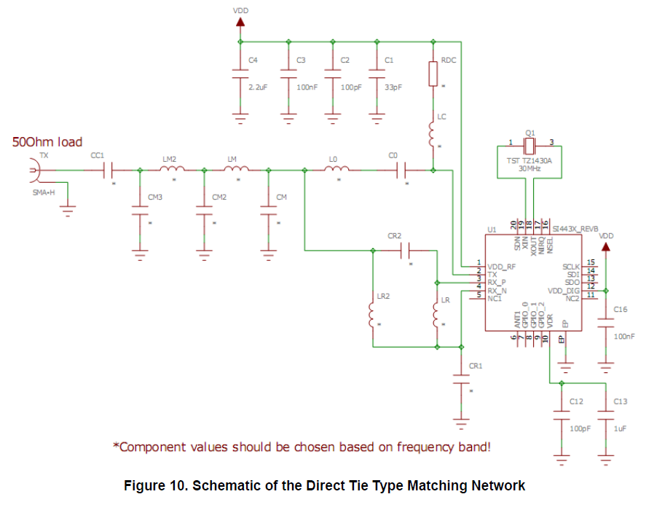
2.1.4. Layout Design Guidelines
The principles in this case are the same as for Split type matching, except for the following issues:
■ To minimize the parasitics (i.e., the length) of the trace connecting the RX and TX sides, the RX side components are closer to the TX side components. Also, because of this, the nearby inductors are not perpendicular to each other.
■ The trace parasitics are very critical for the connection of LR2; so, the shortest traces possible should be used for connecting LR2 to the TX side.
■ Since the RX-TX coupling is not critical, there is not any separating GND metal between the two sides.
    - 布局设计指导
- 在这种情况下的原则是为分体式匹配相同，除了以下问题：
- 为了尽量减少走线连接的RX和TX双方的寄生效应（即长度），RX端组件接近TX端组件。此外，正因为如此，附近电感没有互相垂直。
- LR2的连接是非常关键以免产生寄生效应，因此，应尽可能在最短的走线连接LR2到TX端使用。
- 由于RX与TX的耦合并不重要，没有任何分离的GND金属在双方之间。
Figure 11 illustrates the positioning and orientation of components and ground pour flooding.
图11说明了原件的定位和方向和接地


